# BlueCorpSys Design

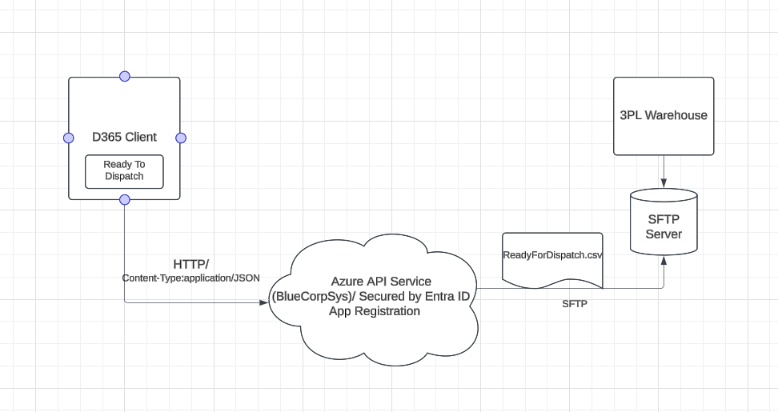

BlueCorpSys API Service Functionalities:

1. Accept HTTP Post Request from D365 Client App (Request Sent by D365 with JSON payload when click on ‘Ready To Dispatch’ button)
2. Read the JSON Structure and Generate the CSV
3. Act as SFTP Client and write the CSV to SFTP Server

Note: BlueCorp API Service supports Token based authentication using MS Entra ID